
Bahria University, Lahore Campus
Department of Computer Science
Lab Journal 08
(Fall 2025)

Course: | Introduction to Data Science - Lab | Date: _______________
Course Code: | CSL-487 | Max Marks: 20
Faculty’s Name: | Mr. Muhammad Umar Tariq

Name: Khawaja Fahad Zia Enroll No: 03-134221-057 Class: BSCS-6A__________

Objective(s):
Upon completion of this lab session, learners will be able to:
- Understand and preprocess a regression dataset (cleaning, encoding, scaling).
- Perform basic EDA to identify key factors affecting house prices.
- Train regression models such as Linear Regression and Random Forest.
- Evaluate model performance using standard regression metrics.
- Make predictions on new data and save the trained model for future use.

Lab Tasks:

Task 2: House Price Prediction (Regression Task)
Scenario:
You have recently joined a real estate analytics company named "HomeValue" as a Junior Data Scientist.
The company wants to build a predictive model to estimate the selling price of houses in different cities.
Management has provided you a dataset named HomeValue_Prices.csv containing 6,000 house records, including numerical and categorical information such as:
- Number of bedrooms
- Number of bathrooms
- Area (in square feet)
- Location
- House age
- Distance from city center
- Whether the house has amenities like parking, garden, or solar system
- Selling Price (target variable)
Your job is to perform a complete end-to-end regression analysis.

Step-by-Step Instructions

Step 1: Data Loading and Initial Inspection
- Load the dataset into a panda DataFrame.
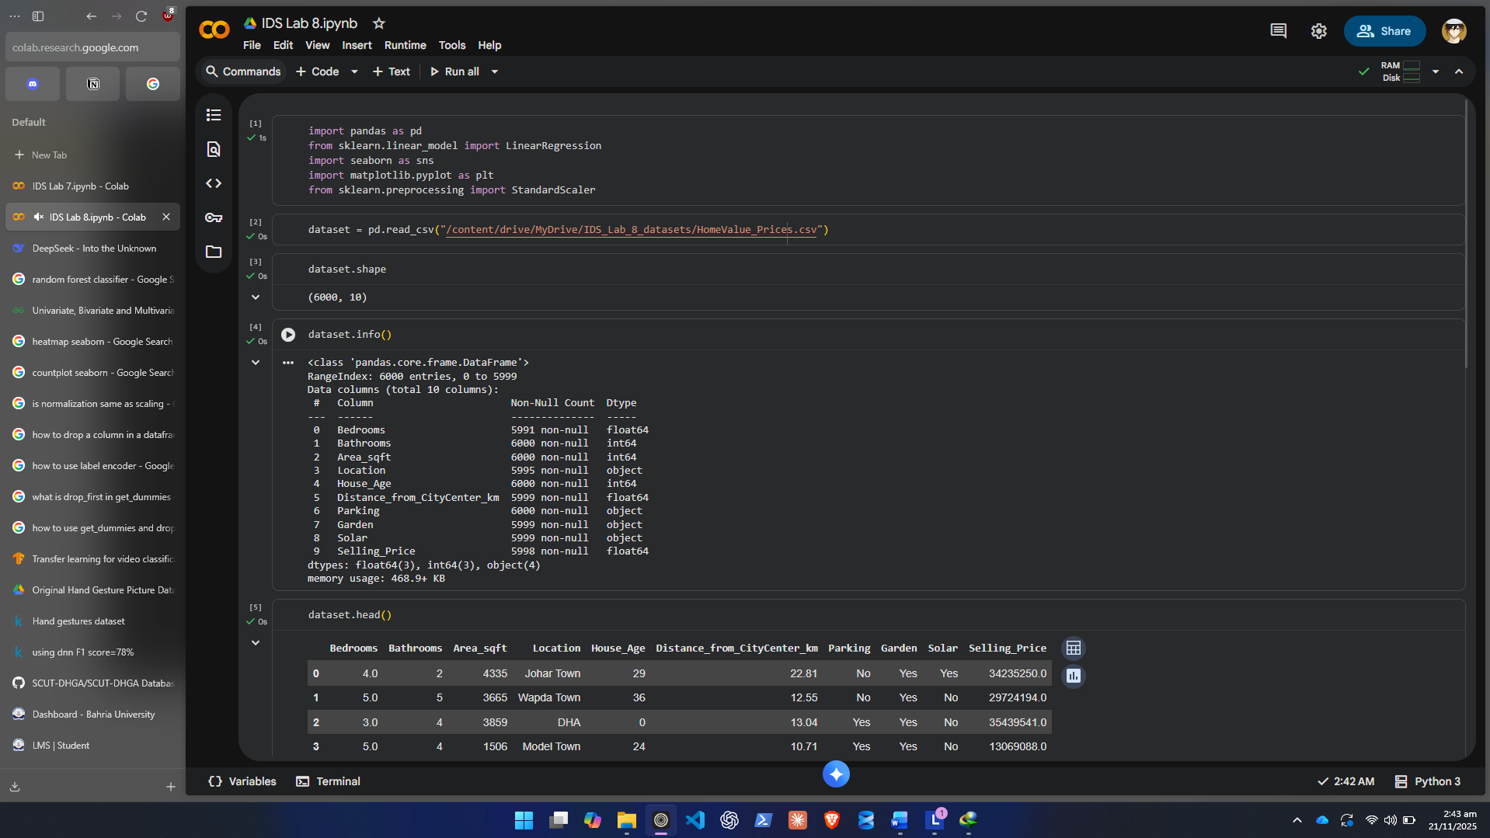
- Display the first 5–10 records to understand the structure.
- Check:
  - Shape of the dataset
  - Column names
  - Data types
  - Missing values
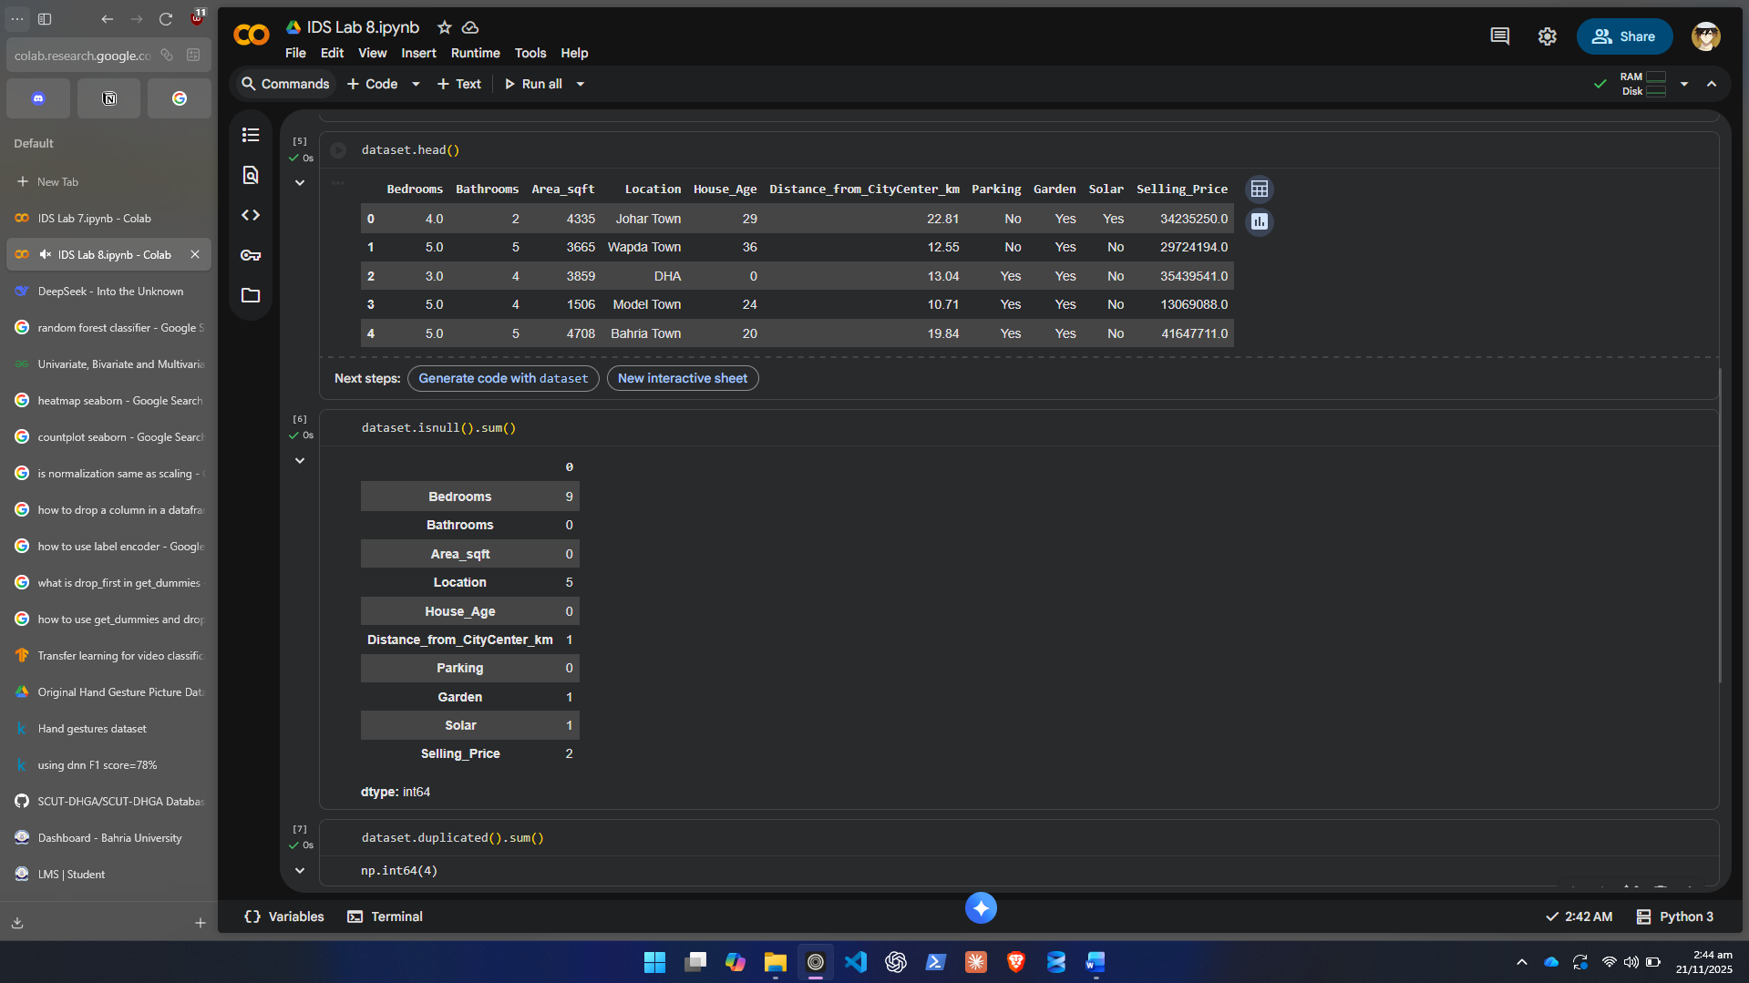
  - Duplicate entries
- Write a short summary of initial observations.
The dataset seems to be inflicted with a few of the common data errors and it seems to record information about different property locations in Lahore and their prices.
Step 2: Data Preprocessing
- Handling Missing Values
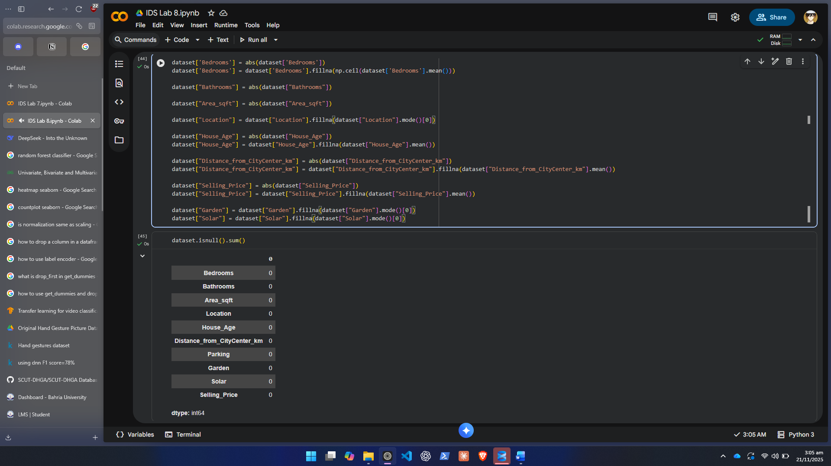
- Duplicate Handling
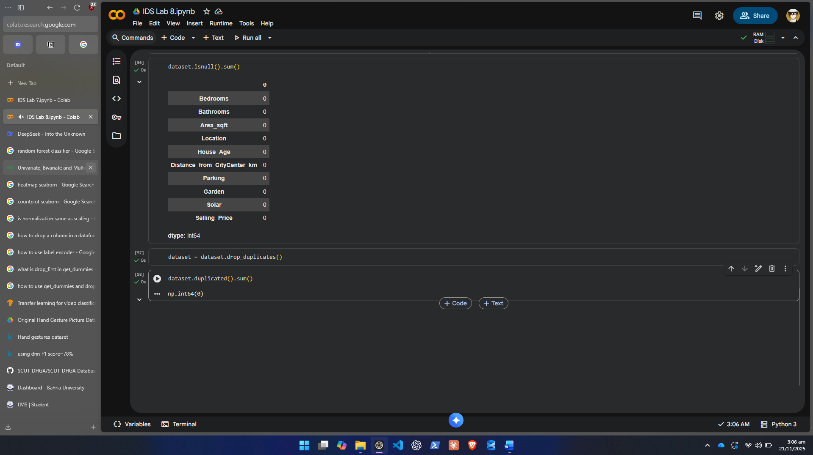

- Encoding Categorical Features
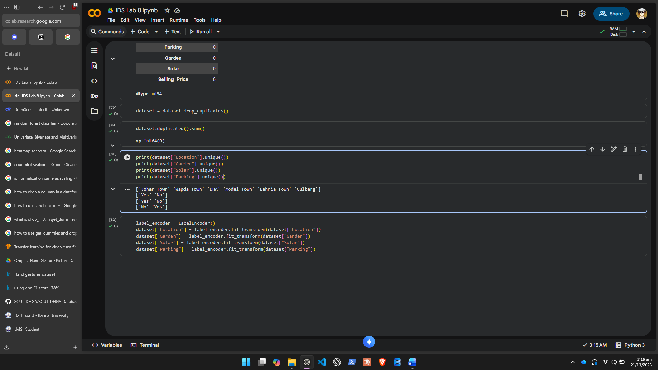
- Feature Scaling
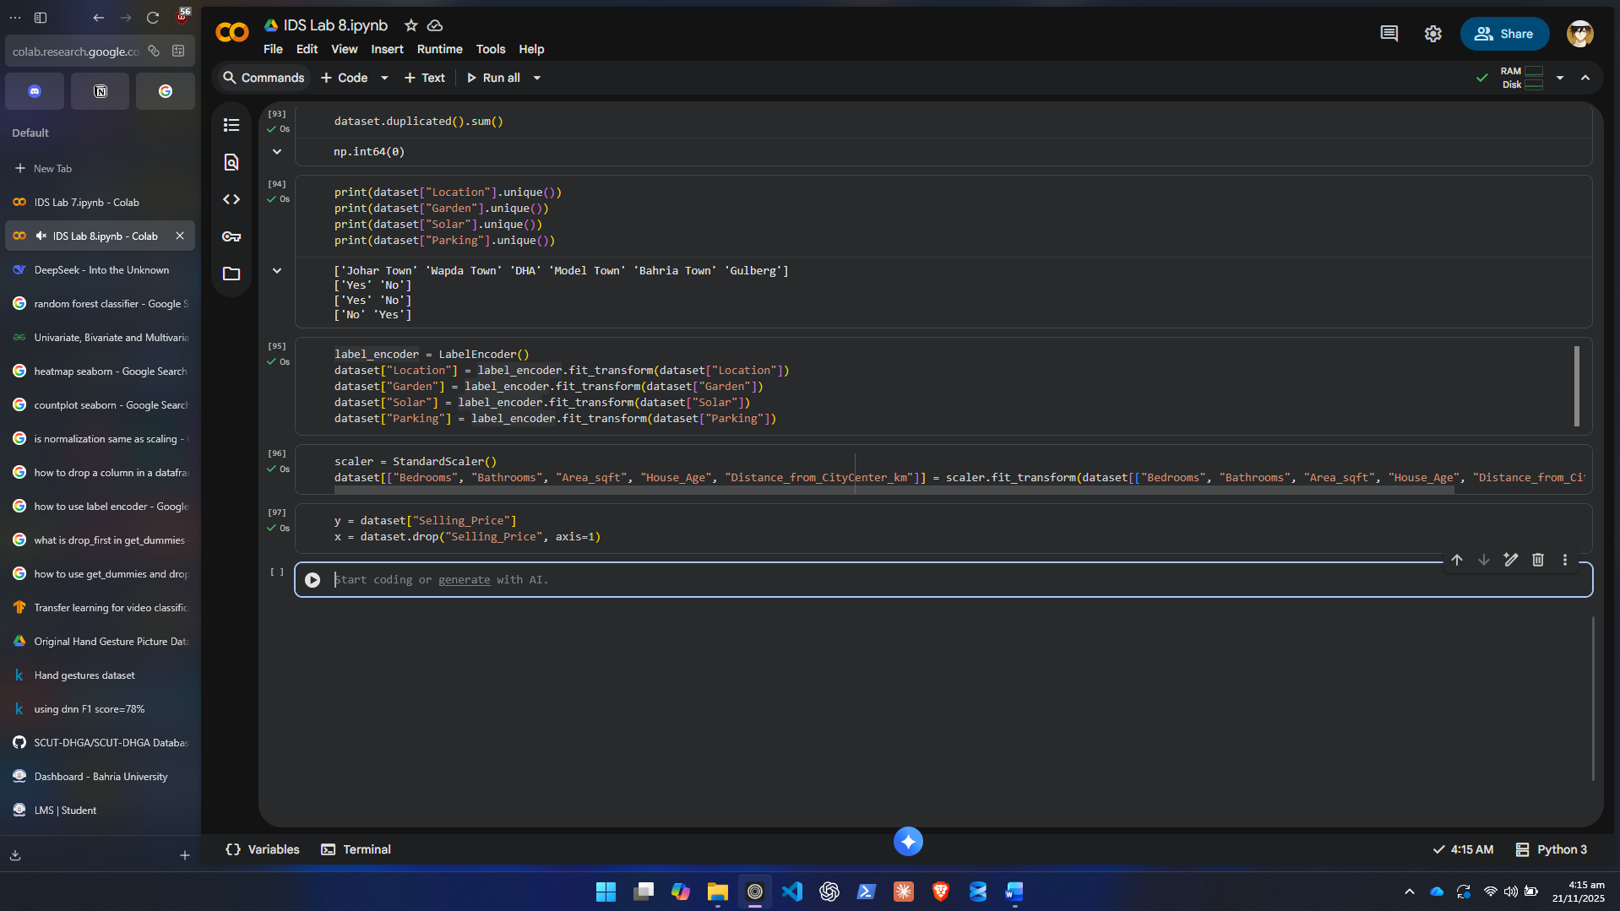

- Final Verification
  - Ensure no missing, duplicate, or inconsistent values remain.
Already done above in each step
Step 3: Exploratory Data Analysis (EDA)
Perform meaningful visual analysis:
3.1 Target Variable Distribution
- Plot distribution of Selling Price using histogram and KDE plot.
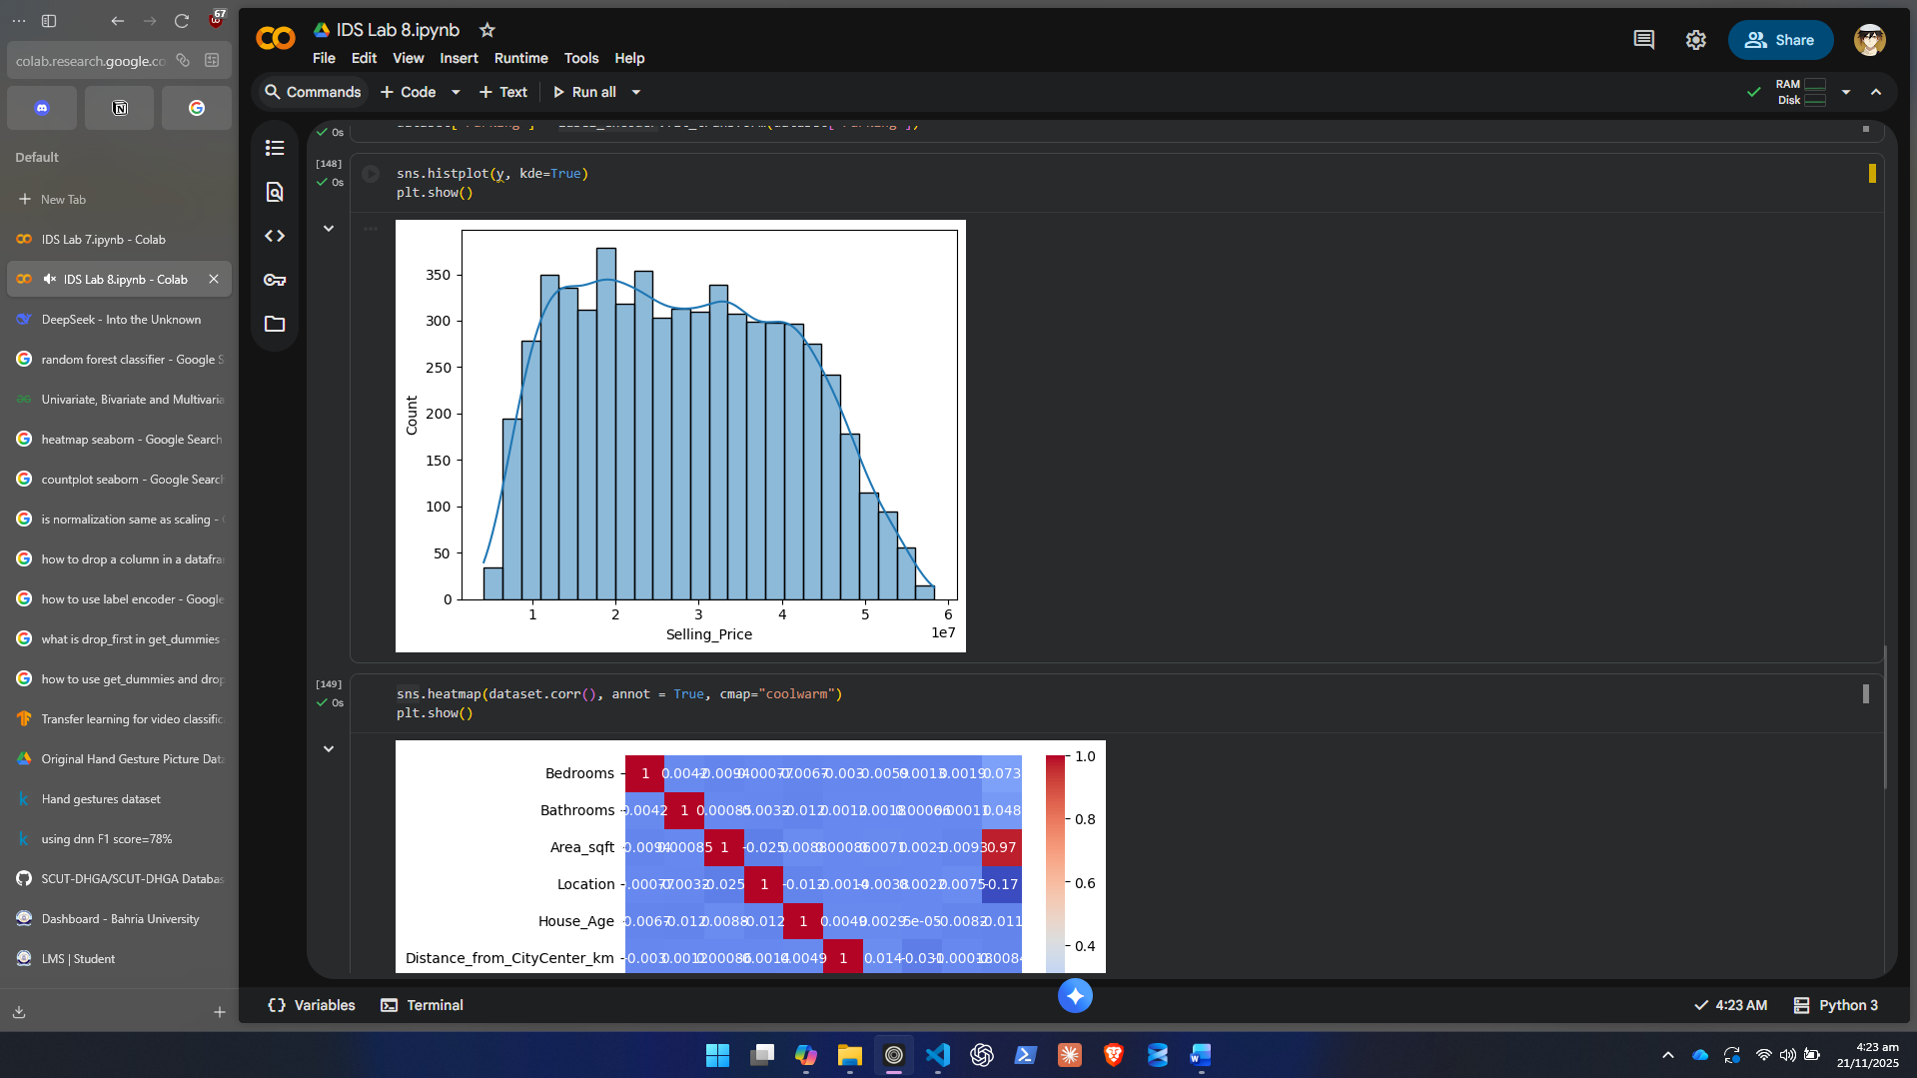
3.2 Correlation Analysis
- Create a correlation heatmap for numerical columns to identify strong relationships
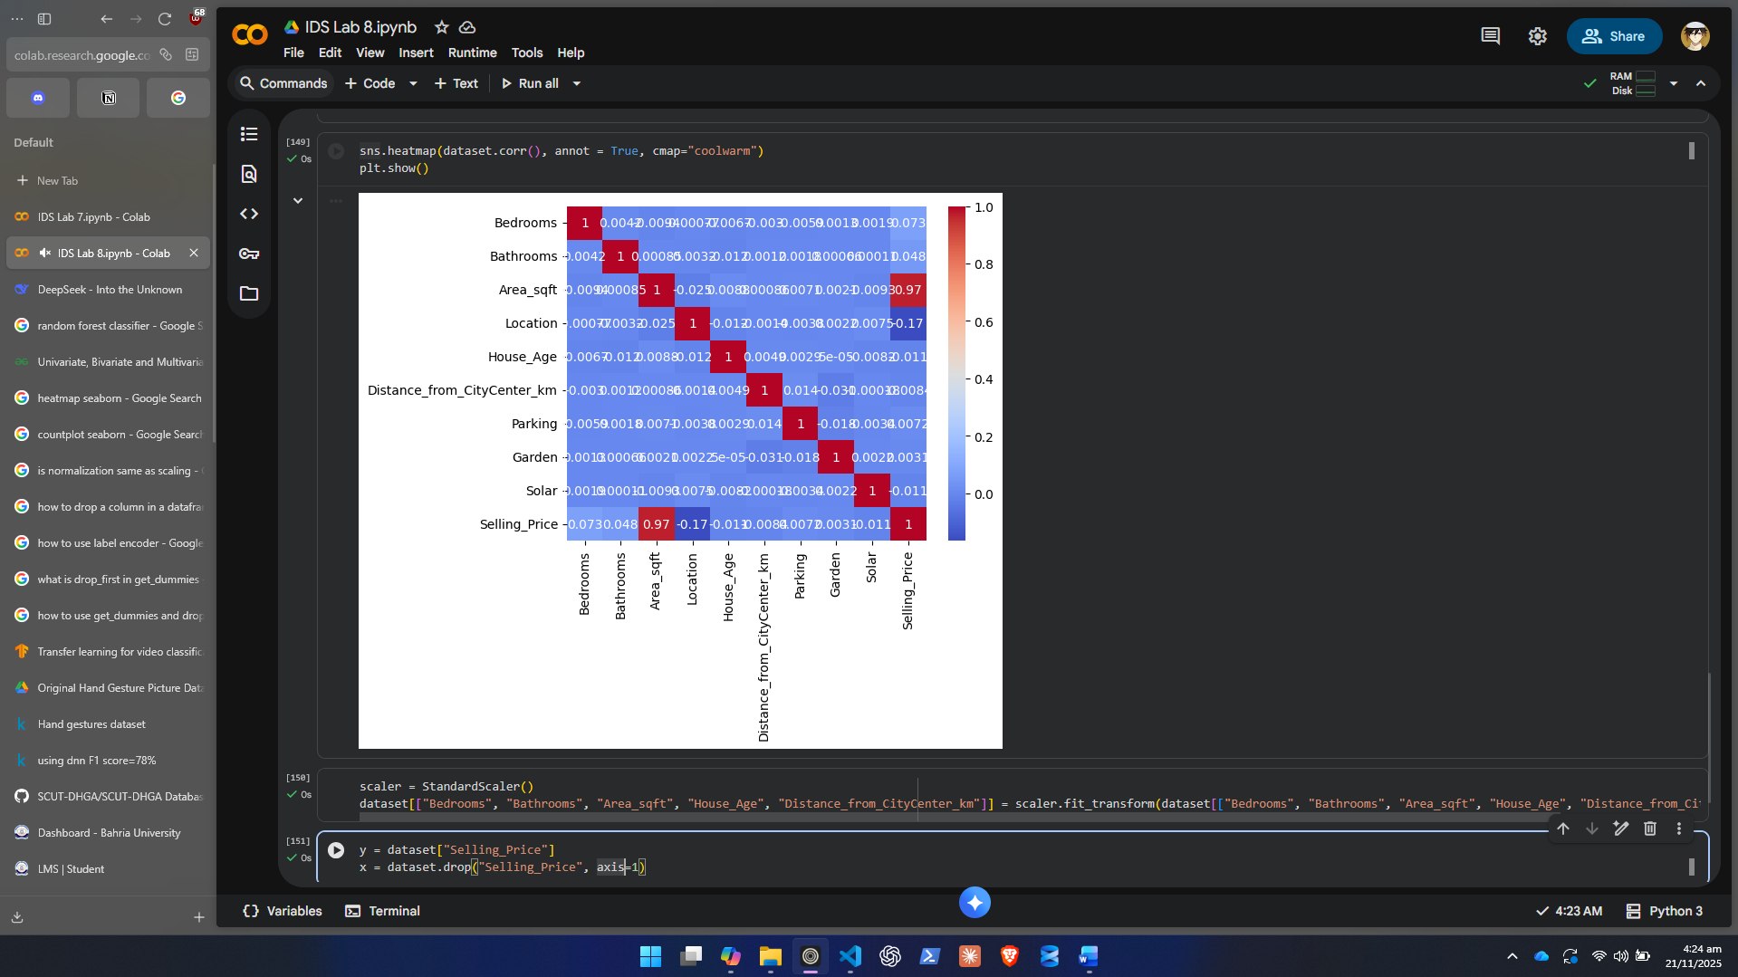
3.3 Relationship Visualizations
- Use scatterplots to study interactions:
  - Area vs Selling Price
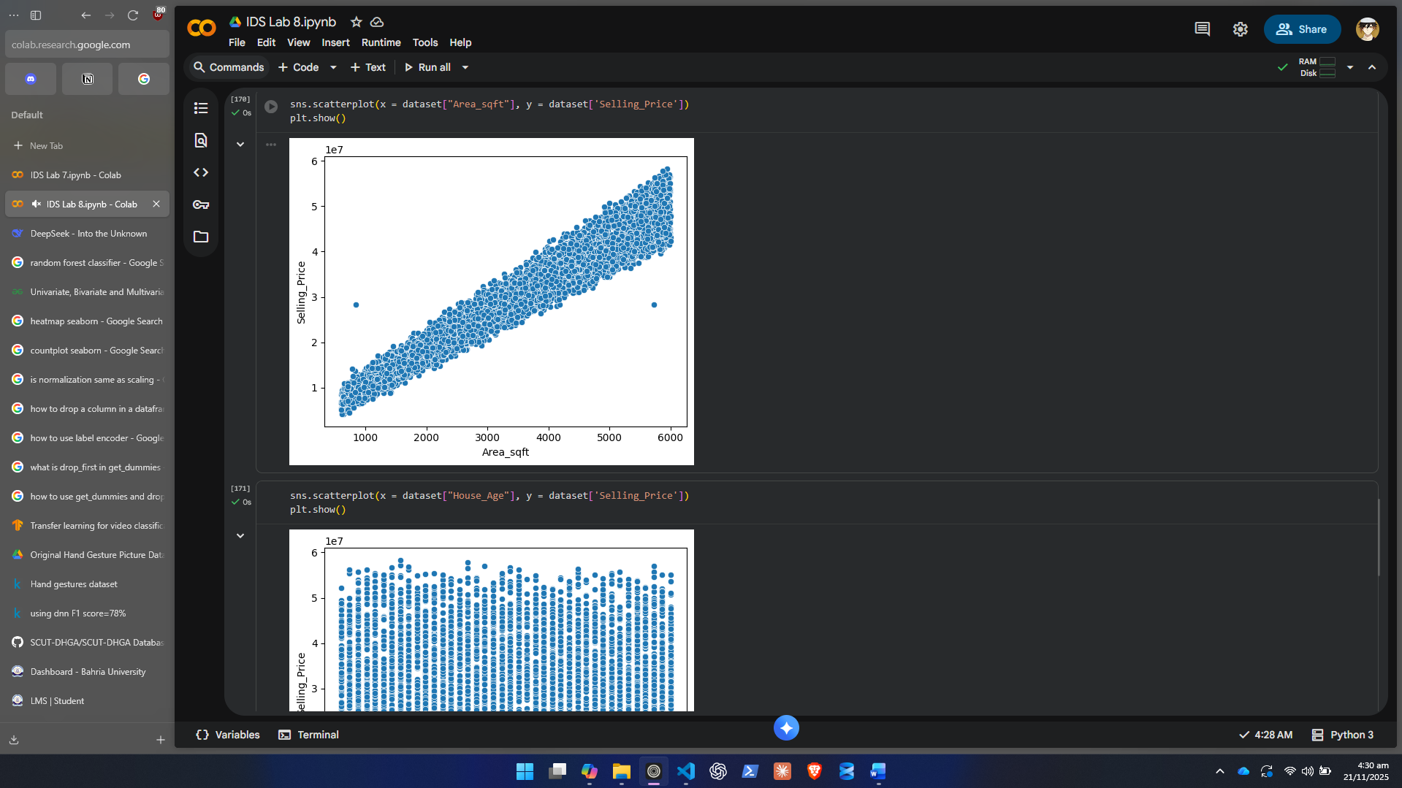
  - House Age vs Price
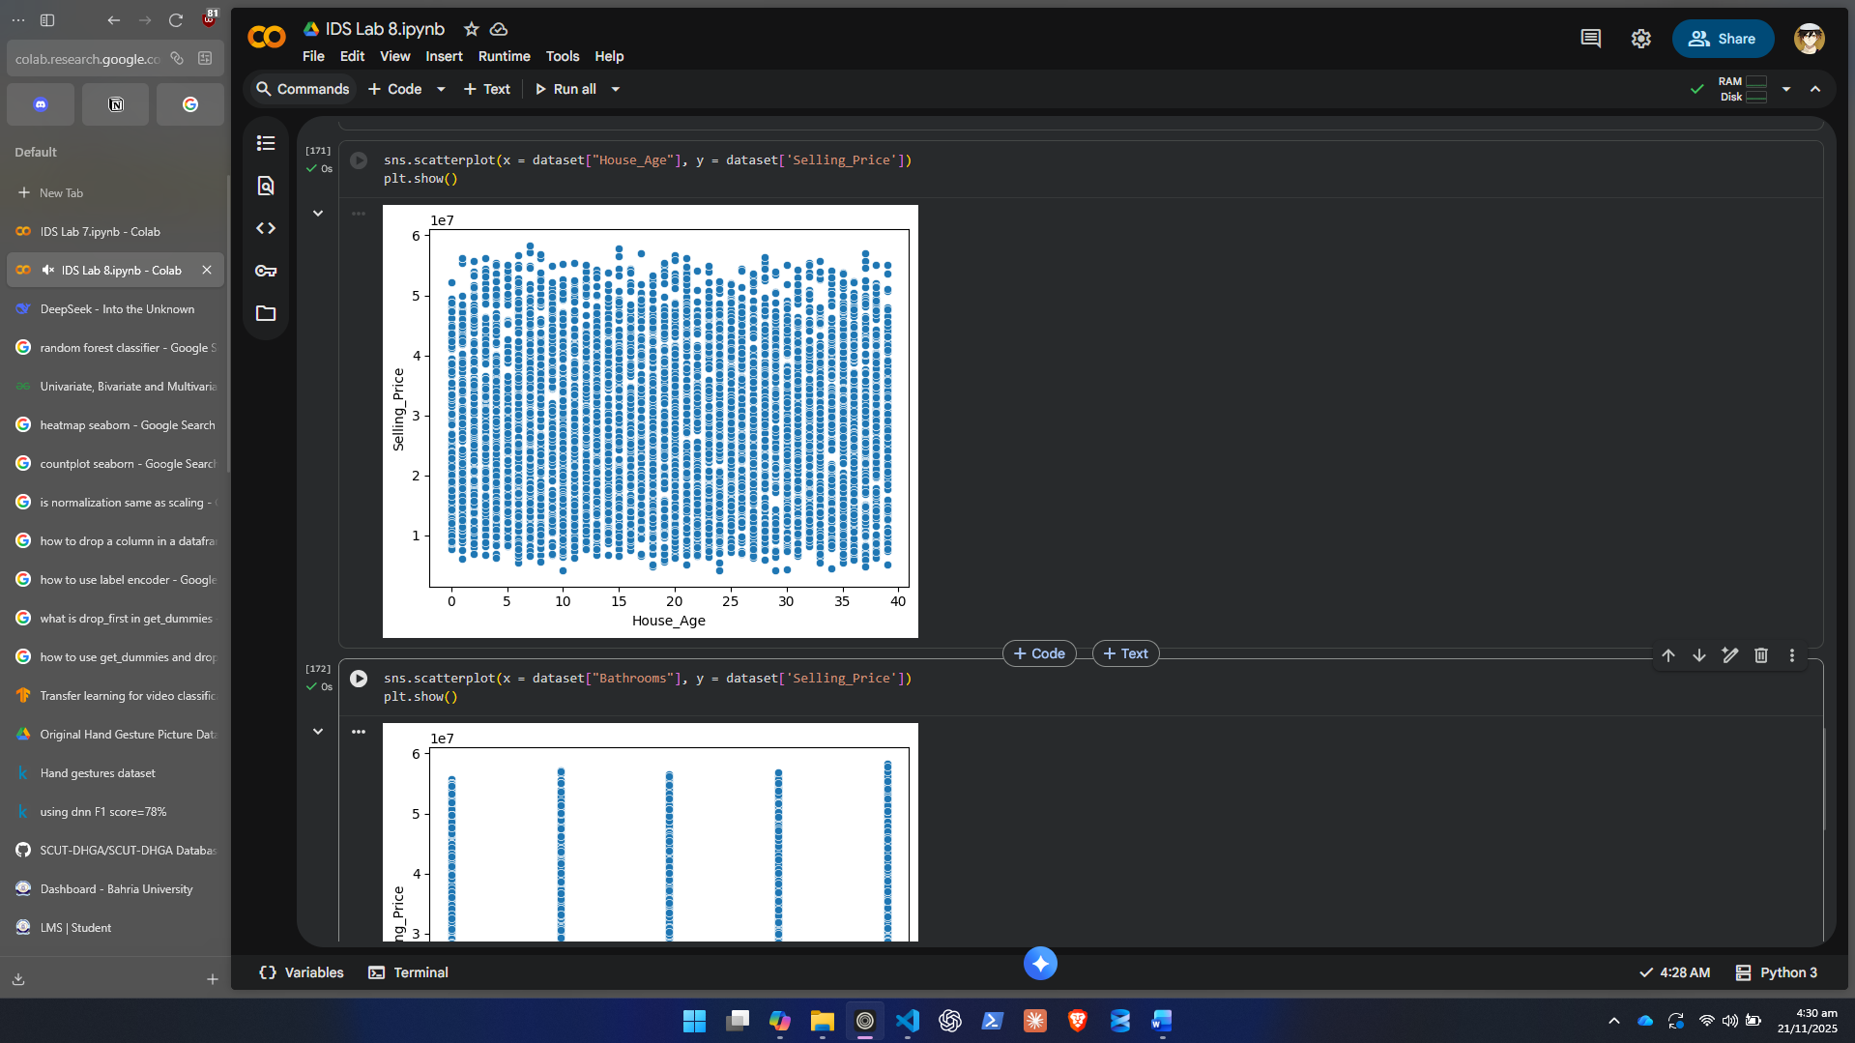
  - Bathrooms vs Price
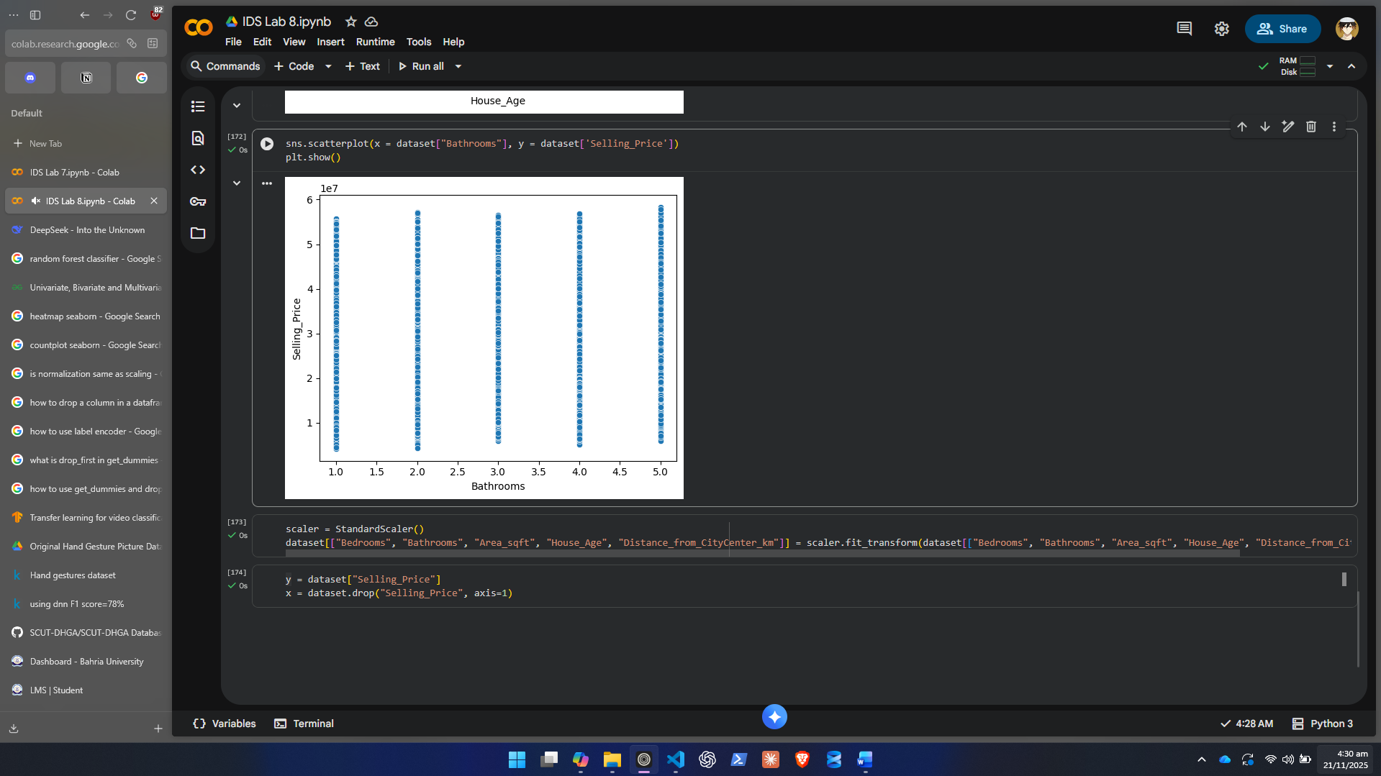

3.4 Categorical Analysis
- Use boxplots or violin plots to compare price differences across categories:
  - Location vs Price
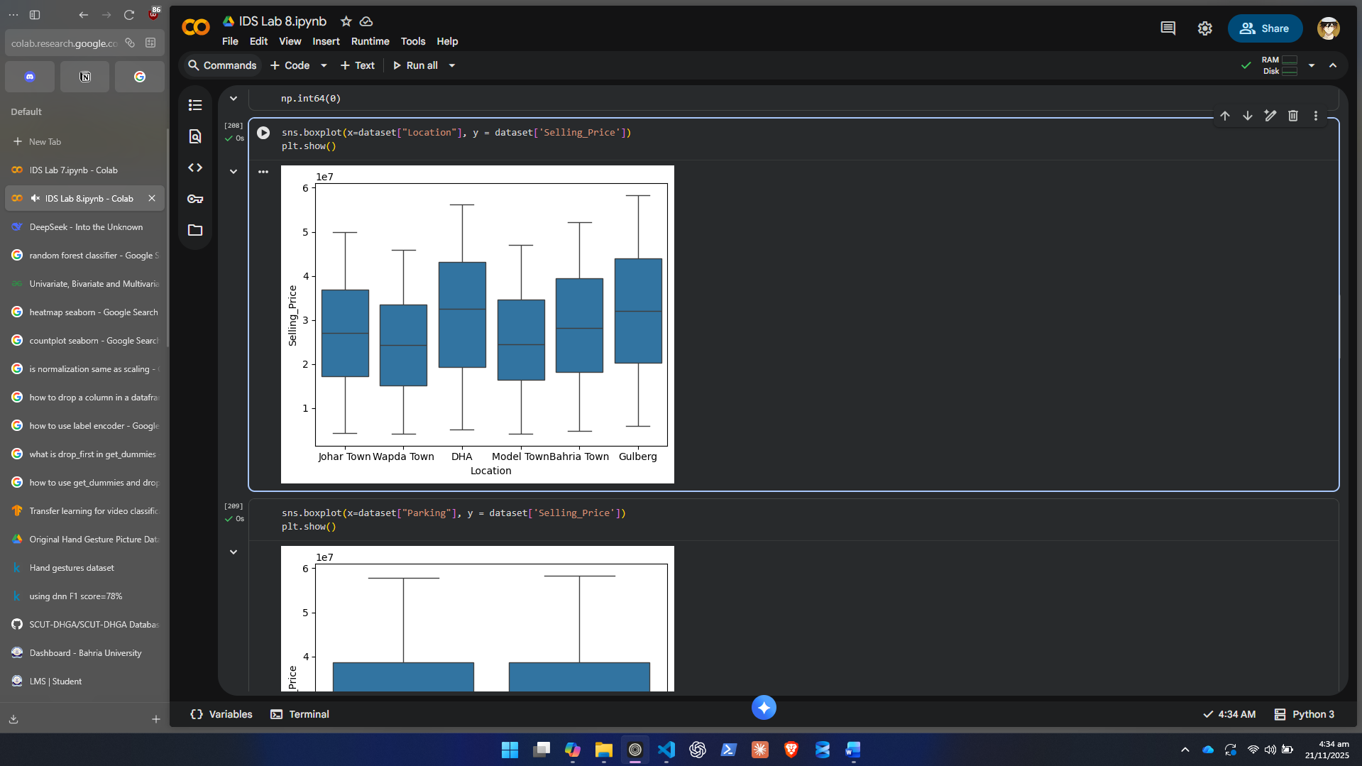
  - Parking Availability vs Price
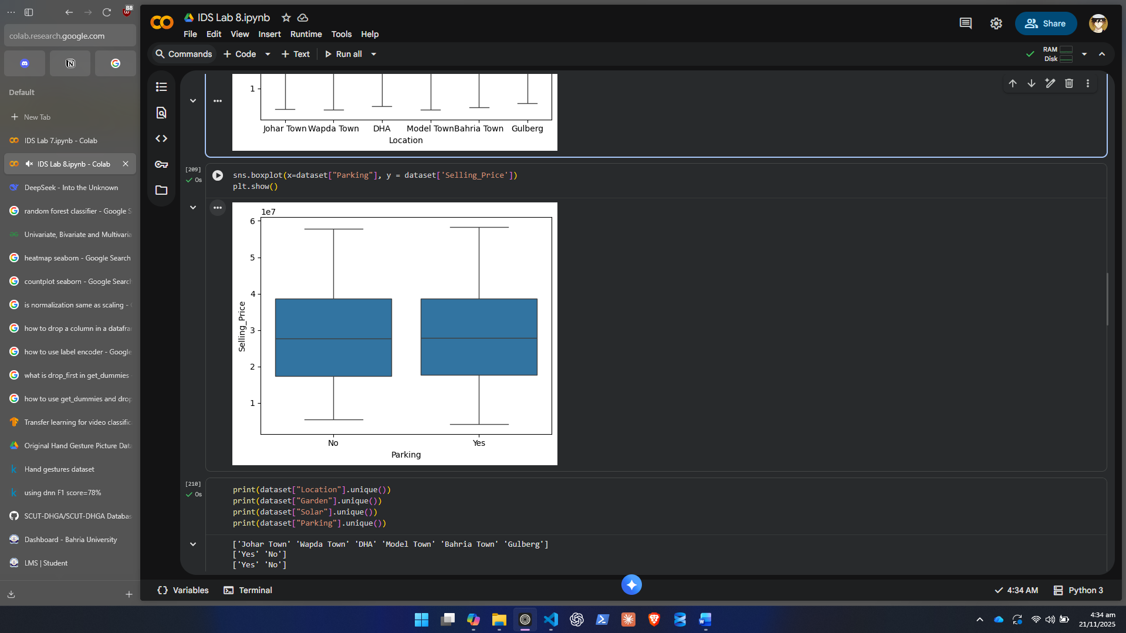

Step 4: Data Splitting and Model Training
4.1 Feature-Target Split
- X = all independent variables
- y = SellingPrice (target)

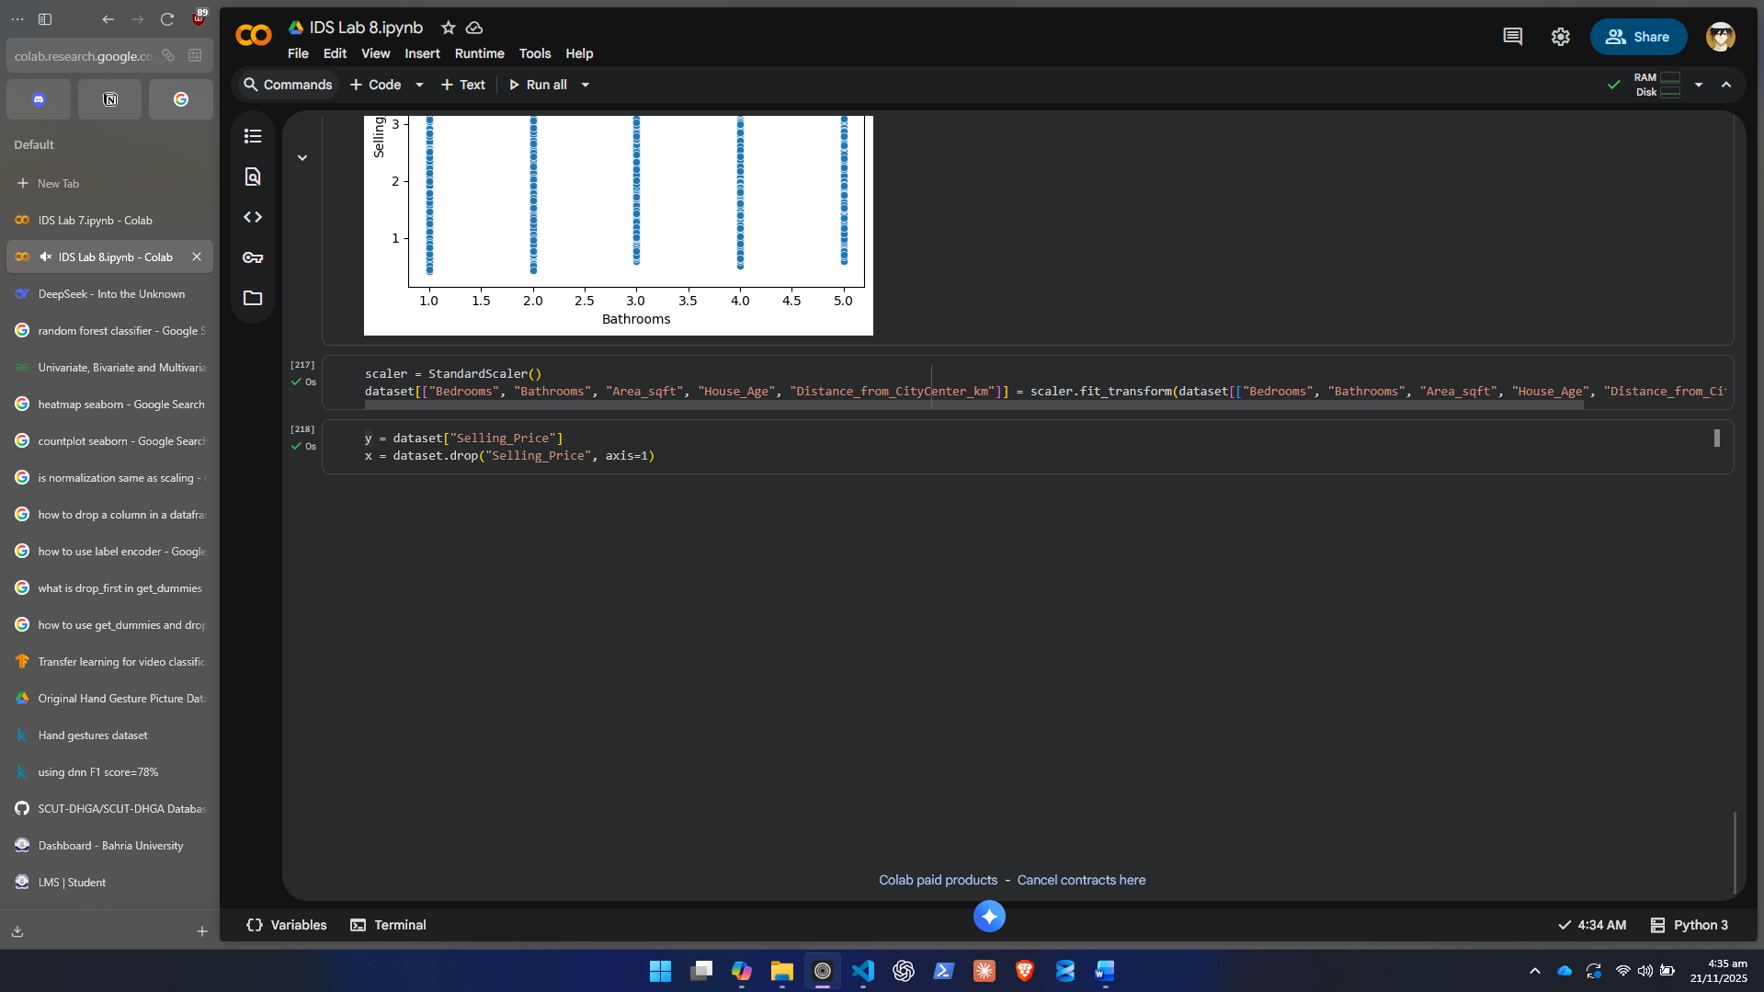
4.2 Train-Test Split
- Split data into:
  - 80% training
  - 20% testing
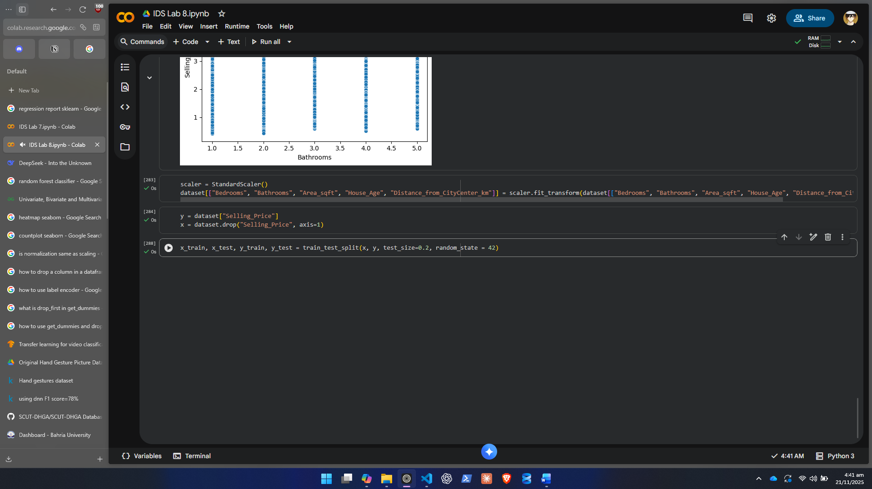
4.3 Train Linear Two Regression
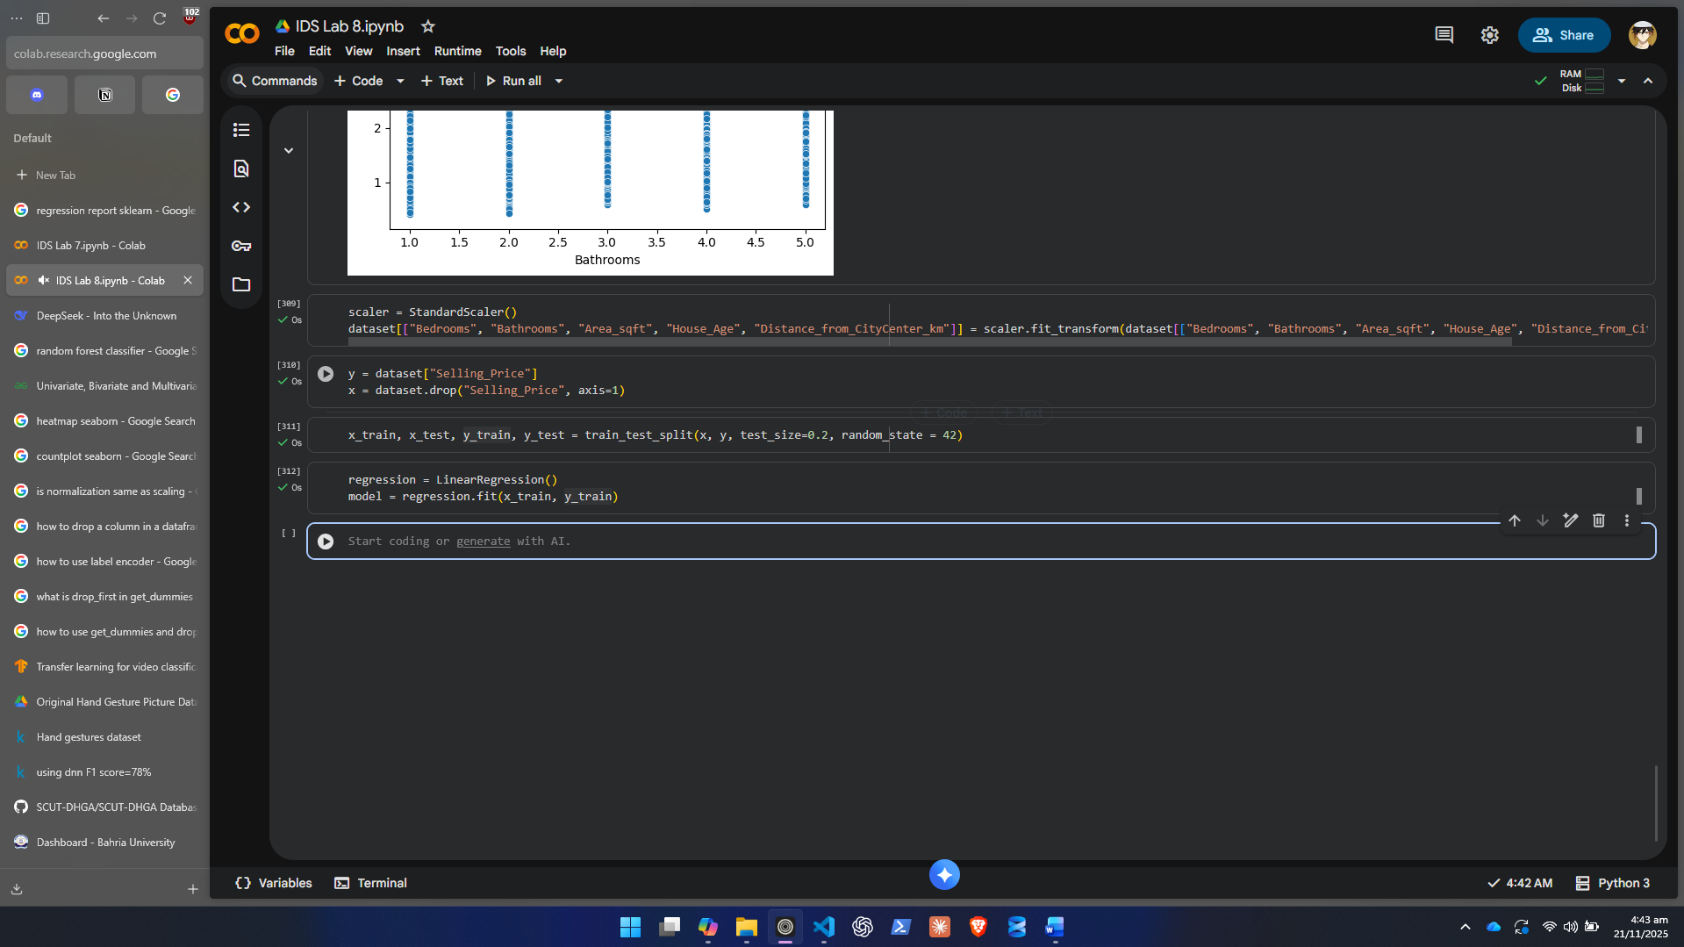
4.4 Evaluate Model:
- R² Score
- Mean Absolute Error (MAE)
- Mean Squared Error (MSE)
- Root Mean Squared Error (RMSE)
Evaluation:
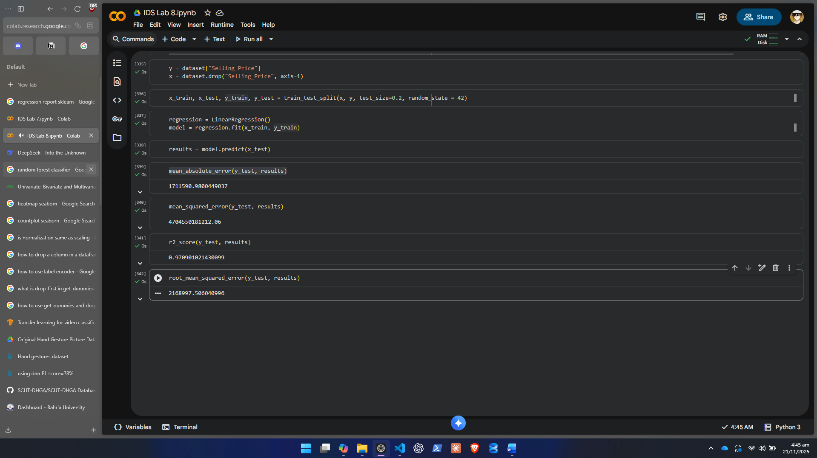
Step 6: Testing the Model on New Input Data
In this step, you will allow the model to make predictions on new, unseen data provided manually by the user.
6.1 Create a Dictionary for New Input
Ask the user to enter values such as:
- Bedrooms
- Bathrooms
- Area
- Location
- House Age
- Distance From City Center
- Parking (Yes/No)
- Garden (Yes/No)
- Solar (Yes/No)
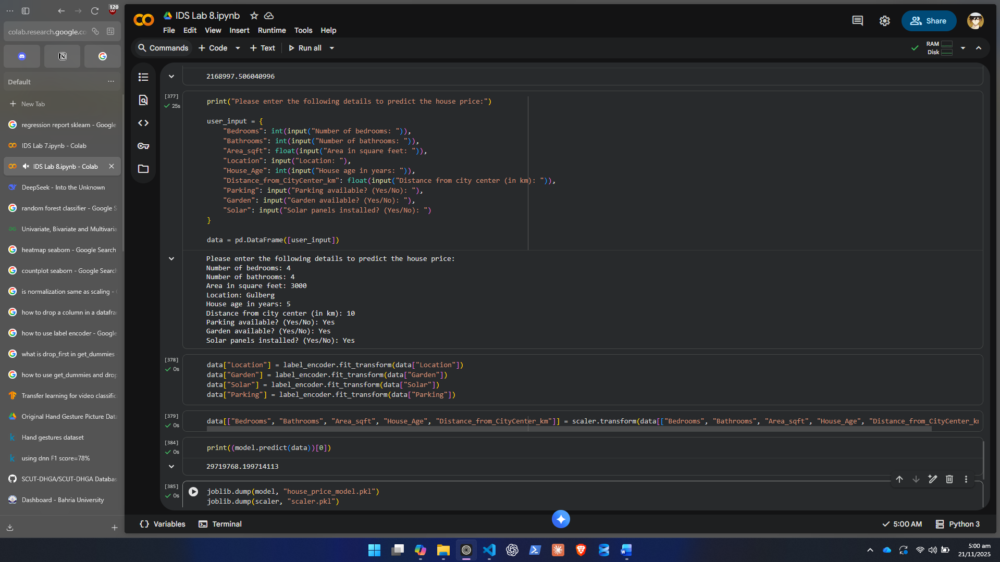
6.2 Convert Input into a DataFrame
- The format must match the training dataset’s feature structure.
6.3 Apply the Same Preprocessing
- Encoding
- Scaling
6.4 Use Trained Model to Predict Price
- Model.predict(new_data)
- Print the predicted selling price.
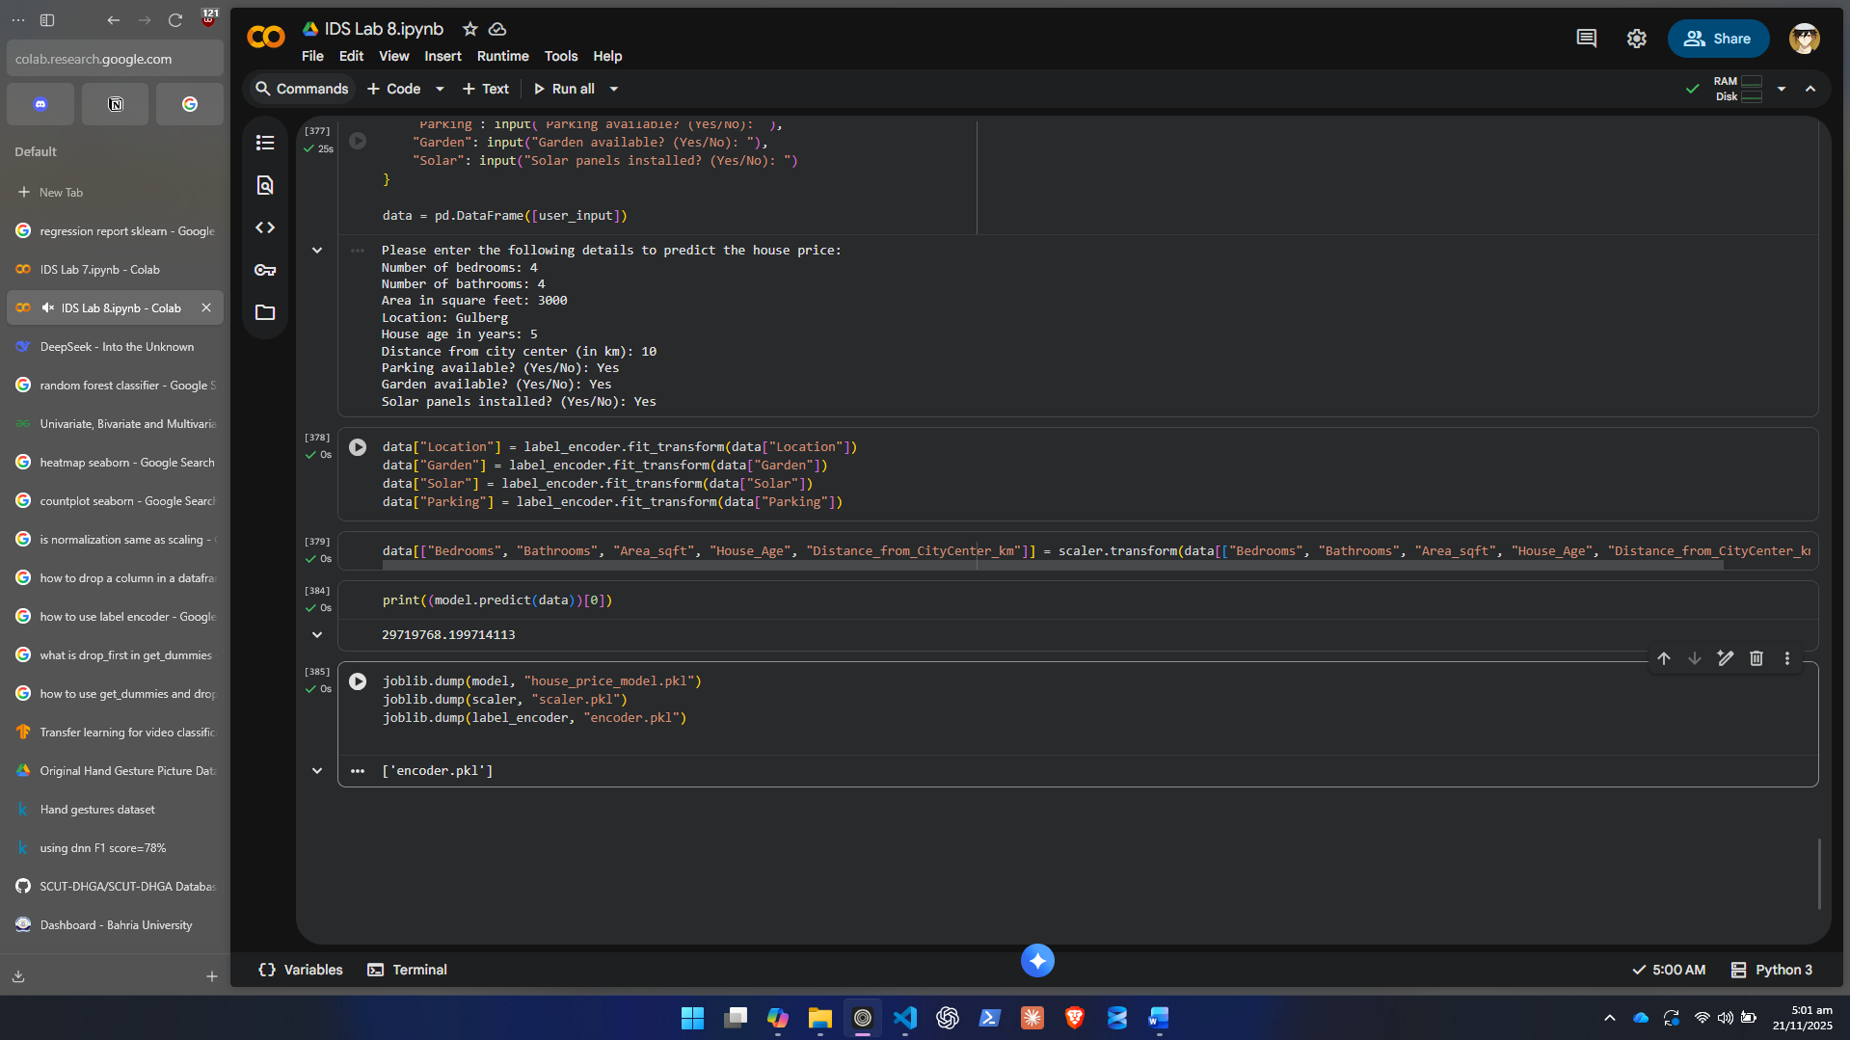
Step 7: Saving the Trained Model
Students must save:
- The trained regression model
- The encoder(s)
- The scaler
So that the model can be used later without retraining.

Step 7: Use joblib or pickle

Using joblib:

import joblib
joblib.dump(model, "house_price_model.pkl")
joblib.dump(scaler, "scaler.pkl")
joblib.dump(encoder, "encoder.pkl")

Using pickle:

import pickle
pickle.dump(model, open("house_price_model.pkl", "wb"))
pickle.dump(scaler, open("scaler.pkl", "wb"))
pickle.dump(encoder, open("encoder.pkl", "wb"))

Lab Grading Sheet:
Task | Max Marks | Obtained Marks | Comments(if any)
1. | 20
Total | 20 |  | Signature

Note : Attempt all tasks and get them checked by your Lab Instructor.

